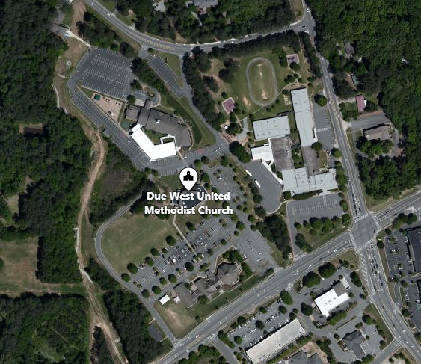

**Preschool Carline Map**

**4’s**

**1’s, 2’s, K Drop Off**

**3’s**

**Due West Road**

**Acworth Due West Road**

**Burnt Hickory Road**

Due West Methodist Church